NPS 2320030205

EXPERIMENT-4 N. Manasa Lahari

AIM: **Construction of Different VLANS and TRUNKING using cisco packet tracer**

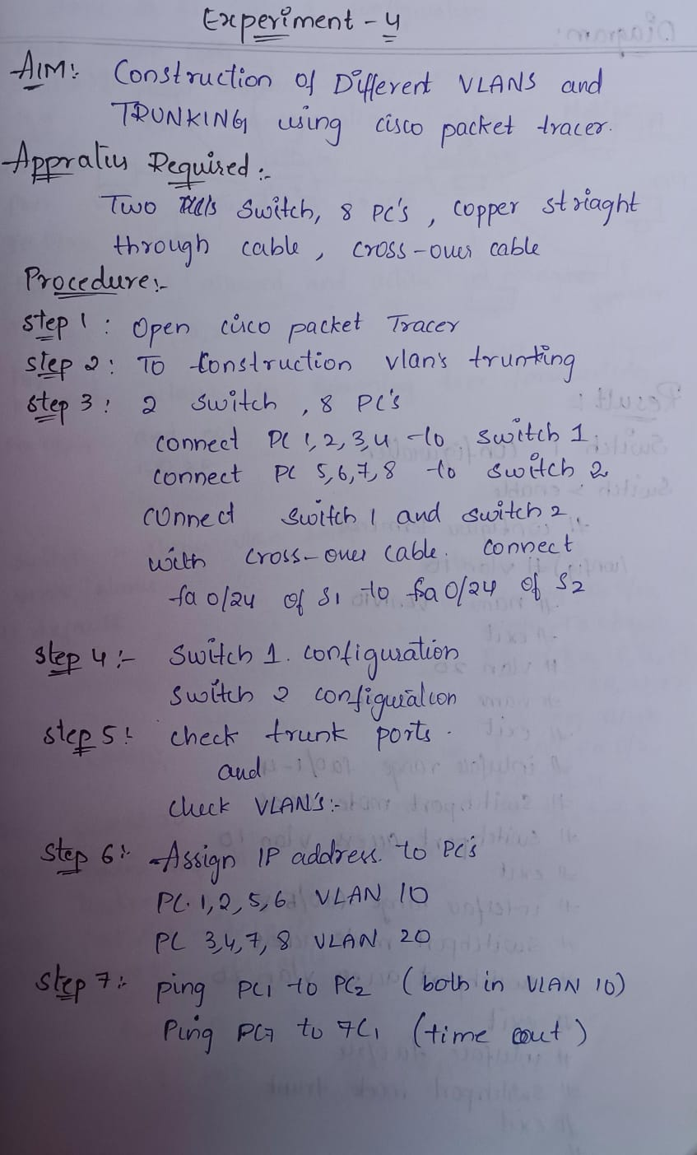

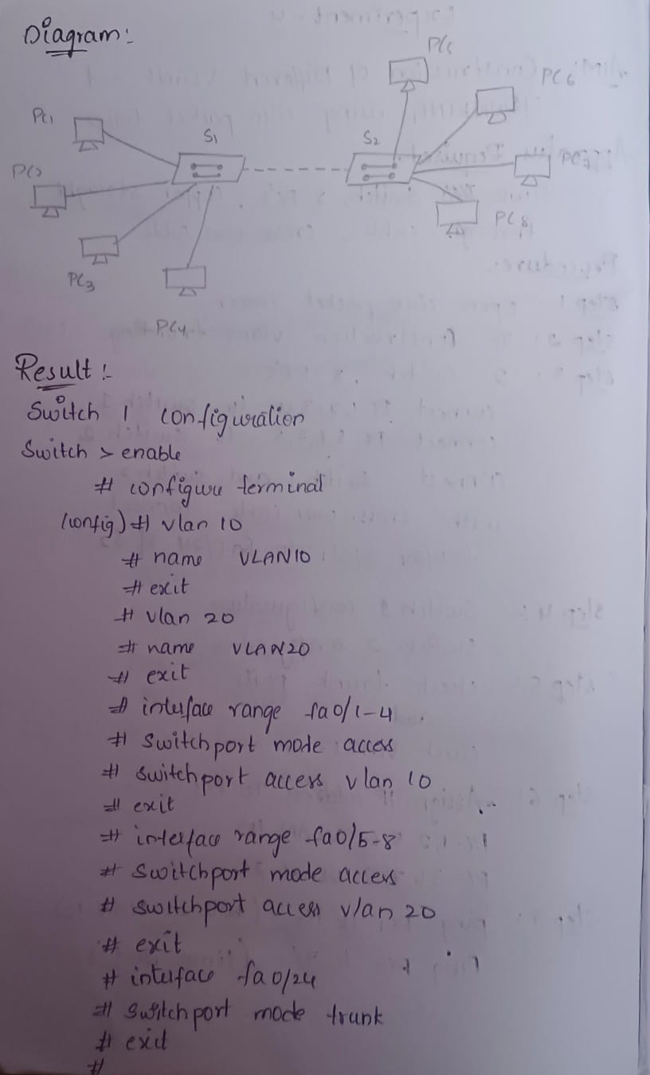

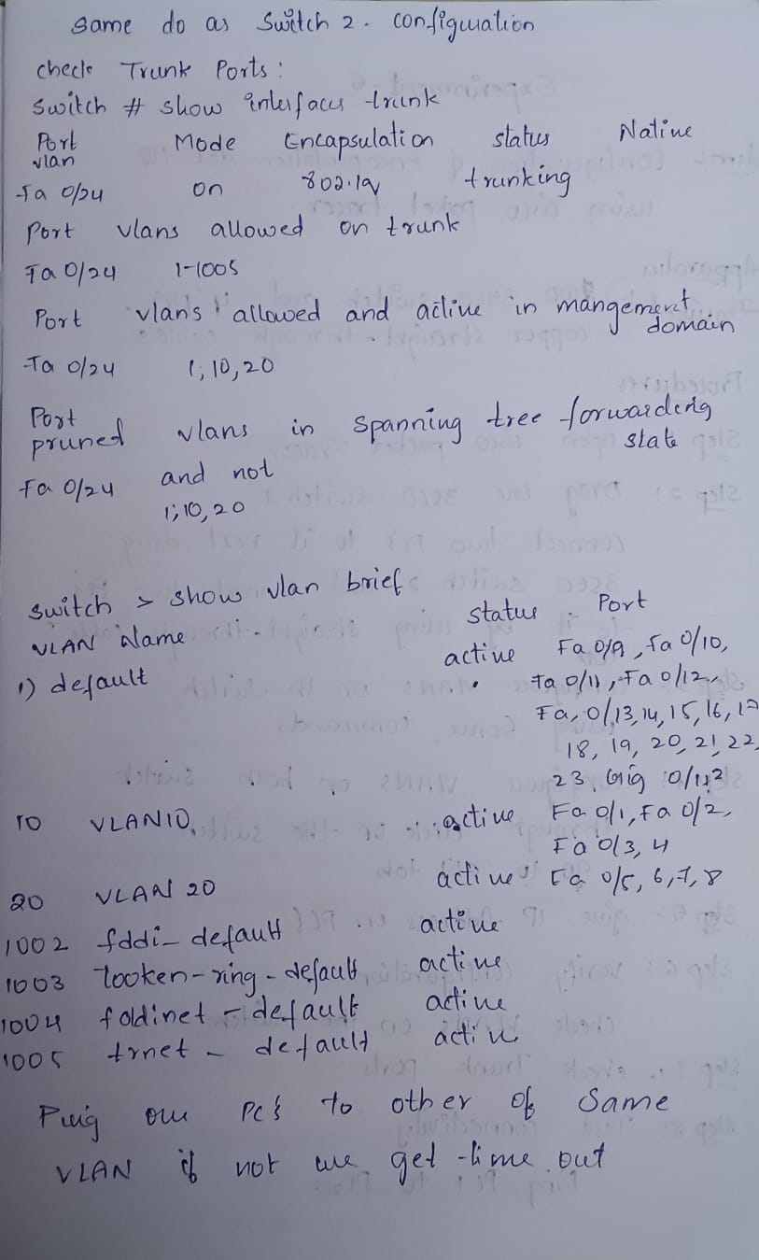

**Switch 0 configuration**

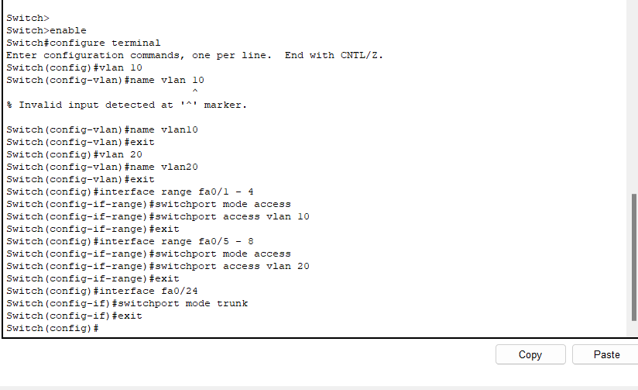

Switch 1 configuration

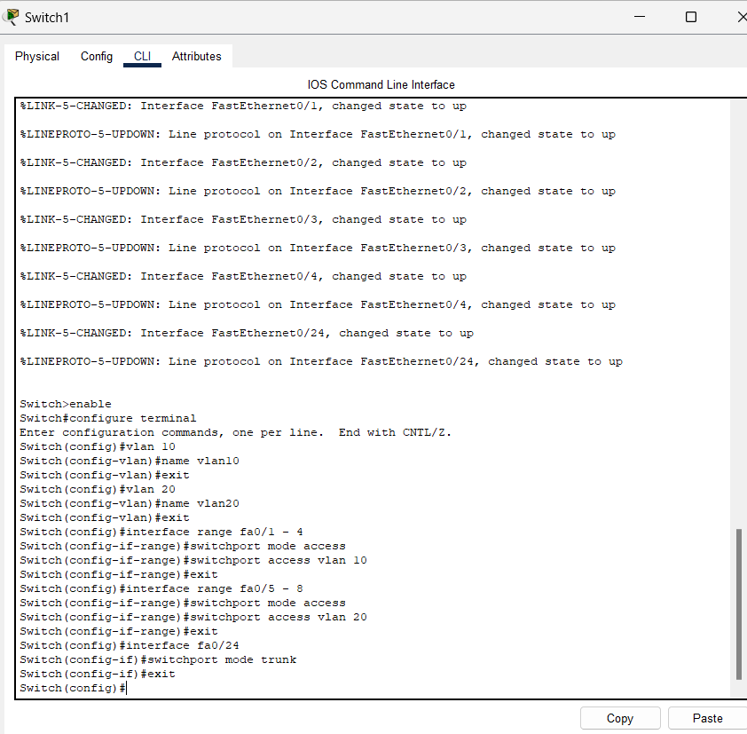

1. **Check Trunk Ports:**

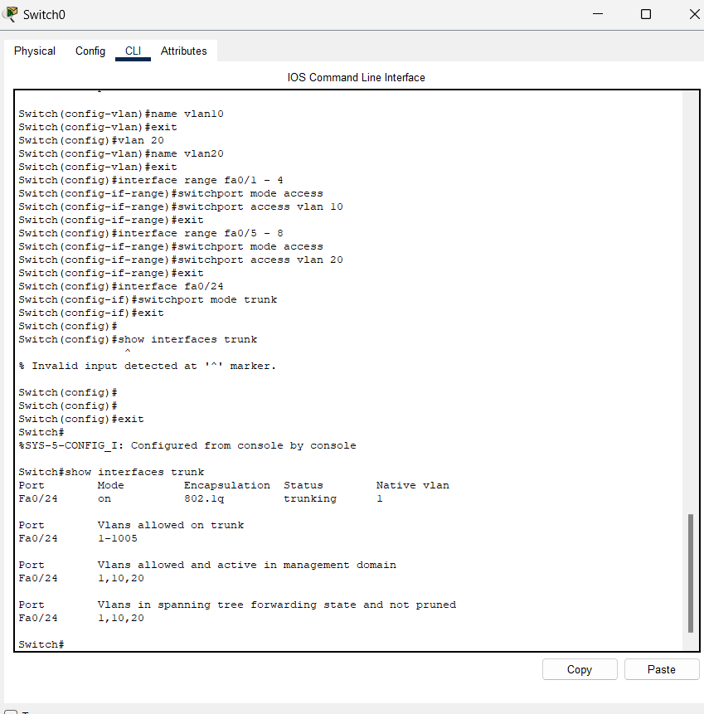

**Check VLANs:**

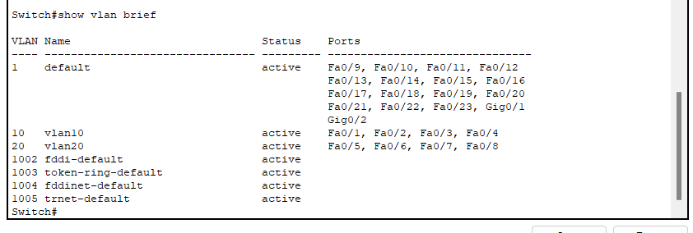

1. **Assign IP Addresses to PCs:**

For pc1

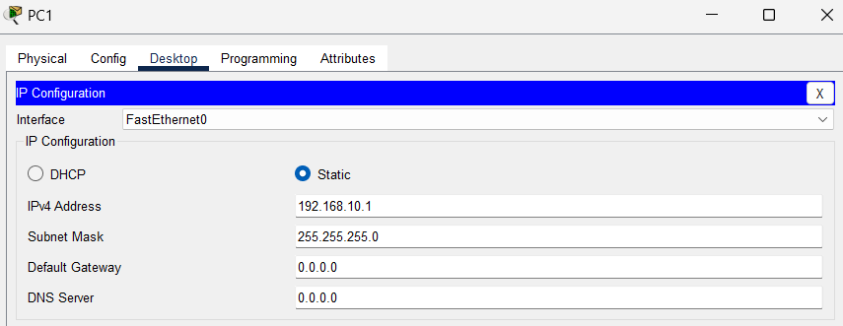

For pc2

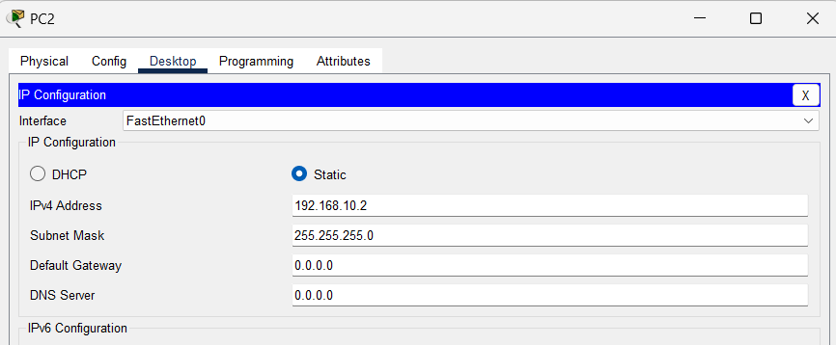

For pc 3

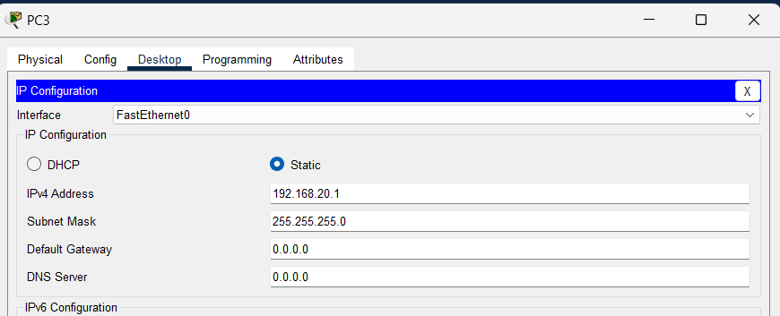

For pc4

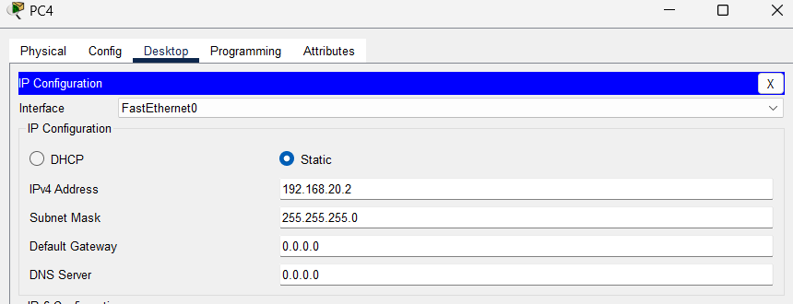

For pc5

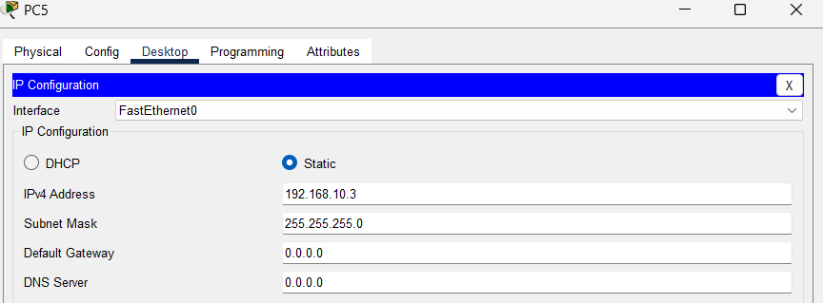

For pc6

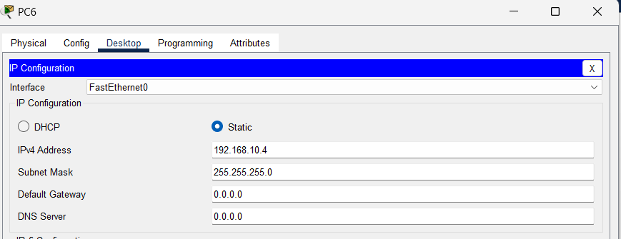

For pc7

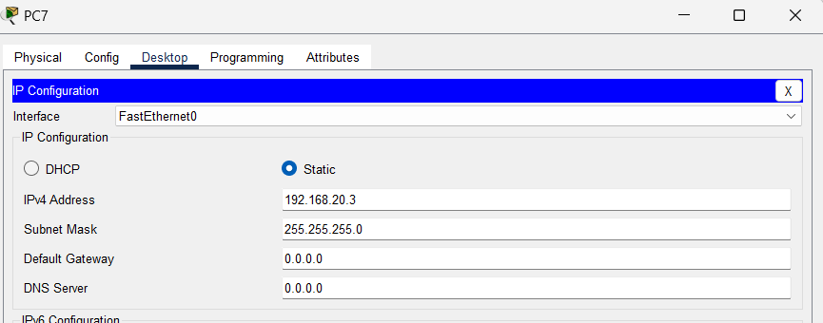

For pc8

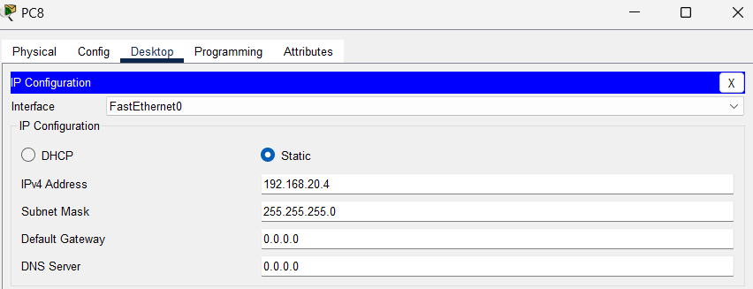

Now **Ping** from **PC1** to **PC2** (both in VLAN 10)

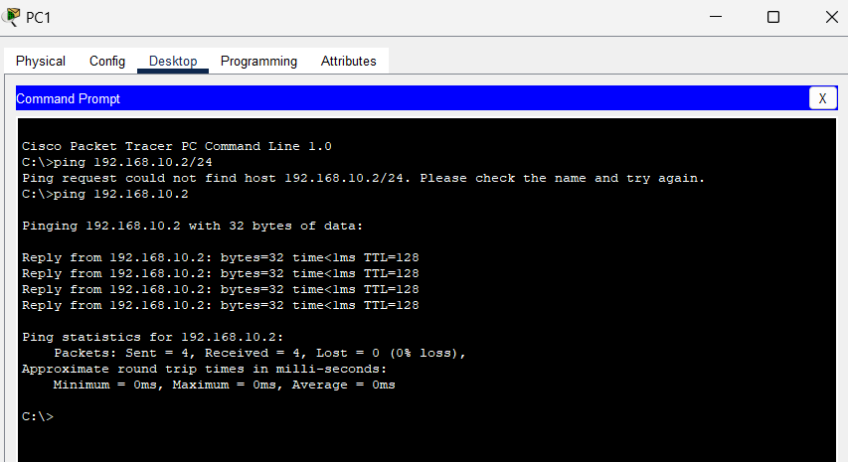

**Ping** from **PC3** to **PC4** (both in VLAN 20)

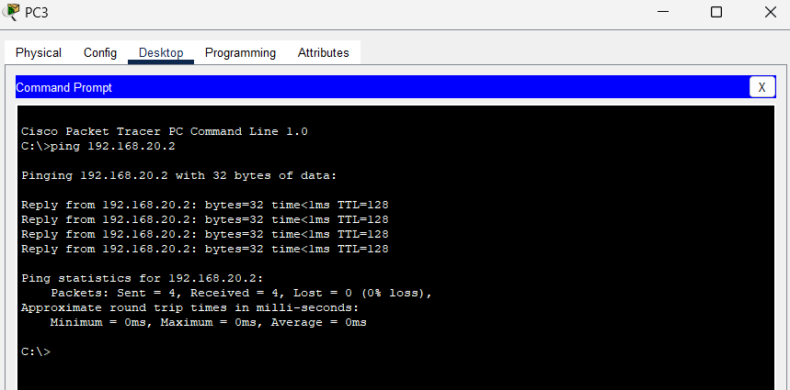

**Ping** from **PC5** to **PC1** (both in VLAN 10, across switches)

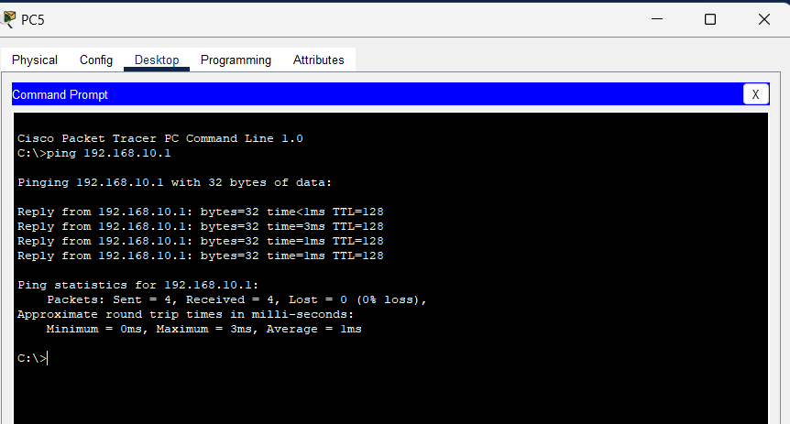

**Ping** from **PC7** to **PC3** (both in VLAN 20, across switches)

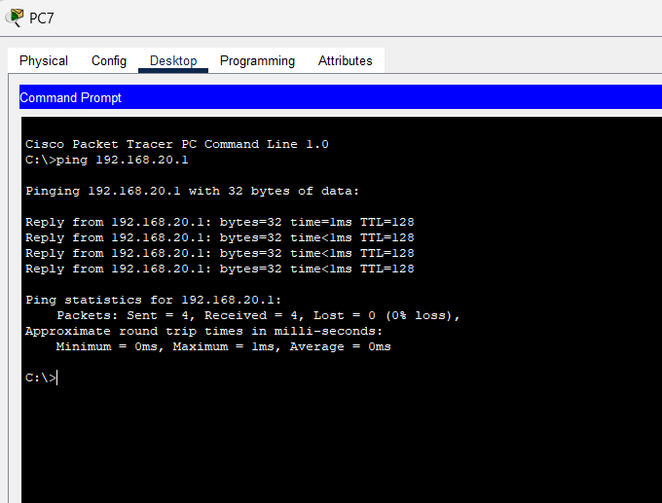

Verify **that PCs in different VLANs cannot communicate without a router:**

**Ping** from **PC1** to **PC3** should fail (VLAN 10 to VLAN 20)

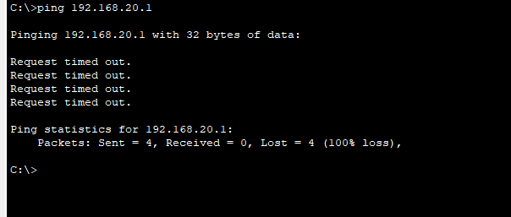

**Ping from PC7 to PC1**

